Project Design Phase-II
Data Flow Diagram & User Stories

Date | 26 October 2026
Team ID | Individual
Project Name | EV Market Intelligence Dashboard (Tableau)
Maximum Marks | 4 Marks

Data Flow Diagrams:
A Data Flow Diagram (DFD) is a traditional visual representation of the information flows within a system. A neat and clear DFD can depict the right amount of the system requirement graphically. It shows how data enters and leaves the system, what changes the information, and where data is stored.
DFD Symbol Legend
Symbol | Name | Description
Oval / Rounded  shape | External Entity | A person, organization, or system outside the project that sends or receives data (e.g., Customer, Payment Gateway).
Rectangle with  numbered header | Process | An activity that transforms incoming data into outgoing data (e.g., Validate Request, Process Order).
Rectangle (solid fill, no number) | Data Store | A place where data is held for later use (e.g., Customer Database, Inventory).
Labeled arrow | Data Flow | The movement of data between entities, processes, and data stores, labeled with what data is being passed.

DFD Level 0 - EV Market Intelligence Dashboard (Tableau)
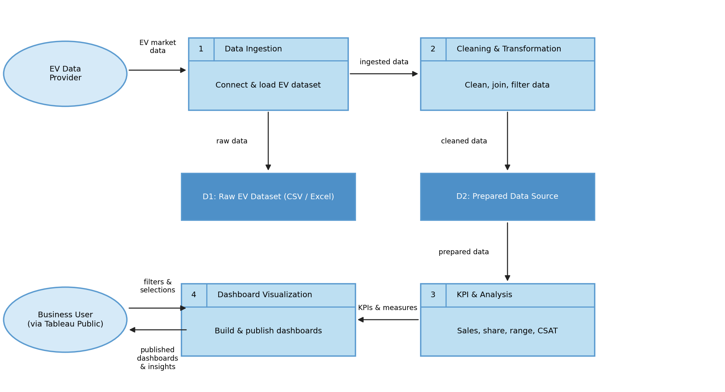

User Stories
Use the below template to list all the user stories for the product.
User Type | Functional Requirement (Epic) | User Story Number | User Story / Task | Acceptance criteria | Priority | Release
Market Strategy Director | Category Sales Analysis | USN-1 | As a Market Strategy Director, I can view annual sales units and revenue by vehicle category so that I can identify the top contributing categories. | All 15 vehicle categories show sales and revenue values | High | Sprint-1
 | Manufacturer Analysis | USN-2 | As a Market Strategy Director, I can see the leading manufacturers by annual sales so that I can benchmark against competitors. | Leaderboard lists manufacturers ranked by annual sales | High | Sprint-1
 | Portfolio Positioning | USN-3 | As a Market Strategy Director, I can compare driving range against sales volume so that I can optimise the product portfolio. | Chart plots range vs sales for each category | Medium | Sprint-2
 | Customer Satisfaction | USN-4 | As a Market Strategy Director, I can view customer satisfaction across segments so that I can find weak product areas. | CSAT pie chart shows segment values on hover | High | Sprint-2
BI Manager | Manufacturer Analysis | USN-5 | As a BI Manager, I can compare manufacturer market share and annual sales so that I can advise clients on competitive advantages. | Market share and sales are visible for each manufacturer | High | Sprint-1
 | Geography | USN-6 | As a BI Manager, I can view manufacturing countries on a map so that I can understand production trends. | Map shows production hubs with country details | Medium | Sprint-2
 | Battery Technology | USN-7 | As a BI Manager, I can see battery technology share (NMC, LFP, NCA, Sodium-Ion, Solid-State) so that I can tell which technology dominates. | Treemap and heatmap show battery share by category | High | Sprint-1
 | Interaction & Filters | USN-8 | As a BI Manager, I can filter by category, manufacturer, country and battery type so that I can focus on a client's market. | Charts update when a filter is selected | High | Sprint-2
Research Analyst | Battery Technology | USN-9 | As a Research Analyst, I can compare average range and customer rating by battery type so that I can study degradation and adoption trends. | Scatter plot shows range vs rating by battery type | High | Sprint-2
 | Range Analysis | USN-10 | As a Research Analyst, I can view average range by vehicle category so that I can track range improvements. | Bar chart shows average range km per category | Medium | Sprint-2
 | Customer Satisfaction | USN-11 | As a Research Analyst, I can see the CSAT and environmental impact matrix so that I can support evidence-based policy. | Matrix shows values for each segment | Medium | Sprint-3
All Users | Access & Sharing | USN-12 | As a user, I can open the published Tableau Public link on any browser so that I can view and share the dashboards. | Dashboard loads from the link without login | Medium | Sprint-3

